GAME DESIGN TEST
Internship

PROFILE

Name: Rebecca Vessal

School – Number of years: 1.5

When are you available (start to end): May 2012 – November 2012

For how many hours a week: 40+ hours

What did you do during your School?
 | Production / Project Management |  | Game Balance
 | Fast Prototyping |  | Interfaces and Menus
 | Machimina / Cinematics |  | Concept Proposal
 | Level Design on AAA Game Editor |  | Mods

Number of projects done (at school & at home): 9
URL of your best project: http://rebeccavessal.wordpress.com/games/spark-crashers/
Are you familiar with game prototyping tools? Y
Rate your knowledge of these tools: (1 Beginner, 4 Expert)
 | 1 | 2 | 3 | 4 |  |  | 1 | 2 | 3 | 4
Tool 1 Visual Studio 2010 |  |  |  |  |  | Tool 3 jGrasp/Eclipse
Tool 2 Flash CS5.5 |  |  |  |  |  | Tool 4 Notepad++
PART ONE: GAME ANALYSIS

FAVOURITE GAMES

List the gaming devices you own or have played a lot (from most recent to oldest):

iTouch 3rd generation, Xbox 360, 3DS, Wii, Gamecube, PS2, PS, DS Lite, Gameboy Advance SP, Gameboy Color, Nintendo 64, Gameboy Pocket, Super Nintendo, PC

Name three AAA games of the past 2 years you have personally enjoyed from a game-design perspective. The games can be of any genre, and on any hardware (iPhone / console / PC / mobile).

Dragon Age II, Portal 2, and Okamiden

Indicate their sales figures and/or ranking when available.

Dragon Age II – Sales Figures: 856,308 in the first 10 weeks of sale Ranking: #338 out of 3,367 Xbox 360 games

Portal II - 1,368,153 in the first 10 weeks of sale Ranking: #13 out of 16,720 PC Games

Okamiden – 309, 484 in the first 10 weeks of sale Ranking: #126 out of 3,472 Nintendo Games

Sales Figures taken from VGChartz. Rankings taken from IGN website.

Select one of the three games you’ve just listed.

Game Chosen: Dragon Age II
All the following questions in this part will refer to this game.

1.1 Game Screenshot
Insert one screenshot that you think best represents in-game action.
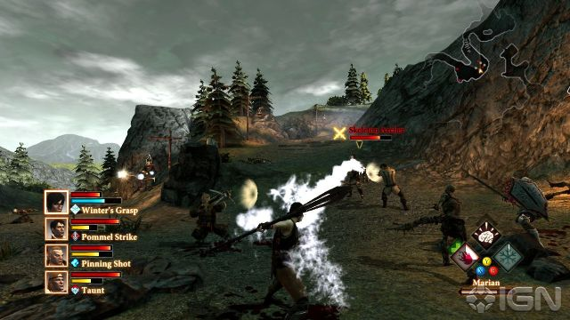
1.2 Game Structure
Describe the game structure:
Main goal:
In Dragon Age II, the user plays as Hawke, a refugee from Ferelden, who must restore their reputation by rising in both power and influence over the various creatures residing in Kirkwall and decide whether to side with the mages or the templars. Even though the story is linear, moral choices come into significant consideration, as it shapes the story of Hawke, champion of Kirkwall. Main quests drive the player through the story with a real time combat system and multiple conversation choices with information needed to continue onto the next quests.

Secondary goals:
Building relationships with other characters in your party and completing side quests. Hawke can pursue a romantic relationship with five other characters. As the characters develop, the player learns how to improve upon specific relationships by choosing favourable conversations with those certain characters. Some characters allow for multiple romantic relationships while others do not. Romantic relationships can be built purely by conversations or by a combination of conversations and gifts. Completing side quests tend to be very rewarding, as they unlock extra cut scenes, build or break relationships with other characters, and offer a chance to obtain powerful weapons and armor. These side quests are what makes Dragon Age II’s story dynamic.

1.3 Memorable Moments
1.3.1 Describe one memorable gameplay moment happening in the game. Add screenshots if necessary.
Memorable moment:
Choosing to side with either the mages or the templars at the end of the game proved to be heart breaking for me. The mages have been subdued by the templars in order to create a fake utopia of peace. Even though not all of the mages know blood magic, they are accused of being a curse in the world that will bring widespread chaos. Most mages have a kind heart and help others with their magic. However, the templars are good by nature, as they bring justice to criminals, who slaughtered innocent people, and protect the citizens of Kirkwall. Dragon Age II’s story compels the player to choose the mages since they are the ones suffering the most from the templar’s reign; however, one of Hawke’s sister is a templar, while the other one is a mage. For the player, there is no right moral choice to save everyone. I chose the templar’s side, because the party members I brought with me suggested to side with the templars. I felt torn apart since I had to kill all of the innocent mages except for Hawke’s sister.

1.3.2 Provide a quick analysis of this memorable sequence: why is it entertaining, why is it successful?
As I said before, there is no right moral choice to choose from. Neither side is completely wrong. No matter what the player’s choice is, the player will murder innocent people. The user cannot choose to be neutral to stay out of the conflict. In addition, Hawke’s party members peer pressure the player to decide whether he or she should side with the mages or the templars. Essentially, the user holds the power to condemn one side by massacring them, thus, changing the major story plot. This one scene plays with the psychology of moral choices, because that one choice makes the player feel guilty throughout the rest of the game. It also makes the user ponder what events would occur if he or she decided to side with the other group.

PART TWO: PLATFORM GAME DESIGN

Goal: define the basic elements of an iPhone platform game (like Rayman, Mario, Sonic…), and create a level using these elements. It must be a side-view game,
Sample target hardware: iPhone 3GS

http://www.apple.com/iphone/specs.html

2.1 Main Character And Abilities

Basic abilities are:

Move to the right

Move to the left

Jump (Jump height = twice the character sprite height)

Crouch

2.1.A) Design the main character, make a short description of him/her below: (no drawing needed)

The player can choose between a female or male chibi cat and the character’s personality becomes determined by the conversations with the NPCs in the game.

The male main character is a gray, spotted exotic domestic cat with a white fluffy mane. His brown spiked collar bone signifies that he escaped from the dog’s mountain detainee camp. A scar runs over his intense green eye. On his large ears, hangs a golden earring with ancient letter carvings engraved in it. White fluffy cuffs surround his ankles, and his tail has several black rings on it.

The female main character is a white Persian cat with a white fluffy mane shaped like a scarf. Unlike the male character, the female one has short ears with a silver earring, attached to a shard of crystal, and a miniscule pink nose. Her bright blue eyes shine like the ocean waters in the sunshine. A blue spiked collar surrounds her neck signifying that she is from the angel cat city. Curved like a bow, her tail stands tall as a proud cat.

2.1.B) Describe the game context shortly (setting, background…)
Before the dogs invaded all of the cat territories, the cats lived in a peaceful utopia. In various cities, domestic cats lived and worked in scratch posts. Exotic domestic cats dominated the pine trees and mountain caves. Both tribes traded and intermingled with each other and formed a cat alliance. Unfortunately, the cats did not know that the dogs have resurrected Cereberus, their previous leader by unlocking the seal on his grave. Once the cats heard of this grave news, they called upon Bestet to save them from the dogs’ wrath; however, Bestet did not answer their cries. With Cereberus on their side, the dogs conquered all of the cat territories one by one and enslaved all of the cats with a spiked collar, each with different colors indicating which region the cat came from. Now all of the buildings in the cat territories are in shambles, and the cats must subjugate themselves to the dogs.
Not all dogs are completely evil; in fact, some of them help out the cats secretly by running underground shelters or assisting them in their escape from the confines.

2.1.C) Define 2 special skills for the hero. Those skills should be available from the beginning of the game.
The first special skill is the claw attack, which serves as a basic attack against dogs and a way to break other game objects. The second special skill is a bite lock-on attack that does more damage than the claw attack, but takes more time to execute and has a longer cool-down period. Bite can also be used to drag blocks to use as stepping stones for reaching the higher parts of the level and to eat food or attempt to eat other game objects. These special skills would satisfy the discovery aspect of games as stated in Leblanc’s Taxonomy of games.

2.1.D) Define 1 special skill that will be unlocked at a specific point in the level (i.e. not available from the beginning of the level).

Note: This skill will be used in the LD of Part three.
The third skill is a switch between party members as the active player. The player can switch between NPC party members by performing a quick double tap on the screen. This allows for the user to play as different cat and dog characters.

2.2 Entertainment Culture / Competitors

2.2.A) Taking examples from other entertainment products (movies, TV shows, music, arts…), what would be the key references for your game? Add visual references if needed.
Greek mythology would be major key reference in my game with Bastet, the goddess of the cats; Cereberus, the three headed dog; greek urns, and barrels. Taking the reference of Cereberus heads’ representing the past, present, and the future, each of his heads can see the past, present, future of the world. Bastet is the cat goddess that the cats called upon the heavens to rescue them from the dogs when Cereberus attacked their territories. Her statue lies inside the cats’ main capital’s shrine.

2.2.A) What are the direct competitors of this game? (i.e. of the same genre, on the same platform). Add screenshots if necessary.
Similar games that contain the same genre and platform that compete with my game are OMG Pirates!, Wind-Up Knight, and Sonic CD.

2.2.B) What are the other competitors of this game in terms of gameplay? (i.e. on any other device). Add screenshots if necessary.
Any role playing game would be competitors for my game in terms of gameplay. Just to name a few: Okamiden, Okami, Kirby games, Mario games, Tales of Symphonia and any other Tales series game, and any Zelda game.
2.3 Controls

2.3.A) Define the controls under the following constraints:

iPhone 3GS

1 virtual pad + 2 buttons.

Double input (i.e.: two simultaneous inputs on different parts of the screen can be detected )

Move to the right: Right on virtual pad

Move to the left: Left on virtual pad

Jump: Up twice on virtual pad

Crouch: Down on virtual pad

Special 1: Paw button

Special 2: Teeth button

Special 3 (to be unlocked later): Double tap

2.3.B) Which specific issues should you cover in order to ensure maximum usability on this touch-screen device?

None of the touch inputs should hinder the player from seeing the action in the game especially during battles. Multiple simultaneous gestures on a small device such as two finger gesture pan are highly not recommended, since they obscure the player from seeing what is happening in the game. All of the graphics should be bitmaps, because the processor of touch-screen devices cannot support high resolution graphics like console games. The only exception to this is sprite sheets, because they must be made as PNGs in order to have a transparent background. If Flash CS5.5 is being used to develop an iPhone game, then motion and classic tweens can be used for sprite animations instead of spritesheets for rapid development. Changing alpha should only occur occasionally throughout the level since it puts a strain on the processor. Controls should be intuitive to the player. Preloading the levels in advance helps to ensure the game will flow more smoothly and prevent future crashes. Buttons and gamepad should be on the bottom of the screen and should be big enough for anyone to interact with. User interface should also be big and clear enough for the player to see, but not taking up too much of the screen space. All game testing should be done on the iPhone 3GS to be sure the game runs perfectly fine.

2.4 Gameplay Elements

The goal of this part is to define the basic level design elements of your game.

Surface properties

The map is composed of different surfaces.

Ex: basic surface is solid ground.

Properties: Objects (including player) collide with the upper part of the tile. Player and NPCs will therefore be able to walk on it.

2.4.A) Define 3 other surfaces

Surface #1: Stats block is a surface block for players, party members, and enemies to jump on

Properties:
Player, party members, and enemies can jump on the black blocks and collide with all sides of the block. Stats block switches between three states: positive, neutral, and negative. Positive, neutral, and negative blocks are represented by the colors: gold, clear, and black respectively. When these blocks are black, they will decrease the player and party members’ strength while increasing the enemies’ strength when walked upon. Walking upon a gold tile increases the player and his or her party members’ strength and decreases the enemies’ strength.

Surface #2: Grass with dirt is a surface block used for cities and rural areas

Properties:
Player, party members, enemies, and other game elements will be on the bottom of the grass, which is essentially colliding with the bottom part of the tile. All game elements will be colliding with the top part of the dirt tile. Therefore the player, party members, and enemies can walk on top of the dirt and bottom of the grass.

Surface #3: Cement is a surface block used as platforms

Properties:
Player, party members, and enemies can collide with all sides. Generally, this surface block is used for generating platforms in the game.

Interactive elements

Players can interact with these elements to reach new places in the level, collect bonuses, destroy enemies or do anything else you want.

For instance: barrels from ‘Donkey Kong Country’, pipes from ‘Mario’, plums from ‘Rayman’.

2.4.B) Define 2 interactive elements and describe the gameplay they create.

Interactive element #1: Urns

Gameplay:

Urns randomly contain food for health, coins, or nothing. This encourages the player to break all of the urns to search for coins and food because of its surprise element. In turn, the player explores the entire level to break every single one of these urns. Also, the urns can be dropped onto dogs by pushing them off platforms.

Interactive element #2: Barrels

Gameplay:

Barrels can contain a pile of fishes that make the player, party members, or the enemies slip or a pile of bones to distract the enemies for a couple of seconds. By attacking these barrels during battle, various strategies can be used to defeat the dogs.

Enemies

2.4.C) Define 2 enemies and describe their behaviour.

Enemy #1: Guard dogs

Behaviour:
They attack cats that approach them, but don’t chase after them too far. All guard dogs have a plate of metal armor on their bodies. In combat, they don’t hesitate and rush straight towards the closest party member to viciously attack him or her with rapid bites. Because of their tenacity, they will pin down the player and execute a heavy bite, dealing heavy damage to him or her. To stop the guard dog from executing that attack, the player or another party member must bite or claw the dog.

Enemy #2: Hunting dogs

Behaviour:

Unlike the guard dogs, they attack the weakest party member in hopes of bringing down the entire party one by one. In addition, they deal a heavy blow each time they attack a party member and then quickly retreat in order to avoid taking damage from the other party members. From experience, they know how to hunt cats and other animals and should be avoided if a party member or the player is in low health.

Rewards

2.4.D) Describe the in-game reward structure (during a level):
The player gains experience from each battle by defeating the dogs. Amounts of experience points gained by the player depending on the difficulty of the enemies. Enemies’ health is slightly randomized in order to keep the player interested in the game. Once a certain amount of experience points are collected, the player levels up and increases his or her strength. Also certain skills are unlocked at certain player levels. In addition, by breaking urns, the player can earn coins for purchasing more customizable options for the player’s appearance at local cat barber shops, health upgrades, and more battle armor or obtain food for regaining health.

2.4.E) Describe the out-game reward structure (in-between levels):
Once a player finishes a level, he or she obtains an armor upgrade. The player can choose from either claw, body, head, or tail armor upgrades per level. These armor upgrades increase defense for the corresponding body part. This gives the player power to decide what upgrades he or she wants to prepare himself or herself for the next level. In addition, these armor upgrades give the game more balance in terms of combat. Later on, body part armors can be sculpted to various shapes to fit the player’s taste.

2.4.F) What kind of behaviour is encouraged by this reward structure?
These reward structures essentially give the player the control over their character in terms of stats and appearance and gives him or her more incentive to complete more levels. The in-game reward structure encourages the player to fight as many dogs as possible and break all of the urns before advancing on to the next level. The player will invest more time into the game by exploring the world, as he or she becomes immersed in the game by having the character be his or her persona.
2.5 Game Audience

2.5.A) List the features that will make your game appealing for a casual audience (i.e. not hardcore gamers)
Just the experience of seeing and playing through a cat’s and dog’s eyes will attract the attention of casual players. Having cute cats and dogs in the game immediately catches the casual audience’s interest. Being able to purchase customizable options for the player’s character will draw people who play the game simply to have an avatar to show to other people and to become in-sync with the character. Controls for the game are intuitive which allows for anyone to easily pick up this game and play it. Levels are quite short in order to allow people to play this game on their small breaks. The player has the option to play with other players on the same network. Those other players would be the party members for the first player. Max number of players allowed per game is four since having too many players in one game would cause major lag.

2.5.B) Which additional features will you add to make it also appealing to a mass-market audience?

The ability to customize your character in the beginning of the game will ensure that the player to connect more with the main character. Also, the player can customize his or her own cat house by purchasing furniture and toys for it with coins. Coins can also be found in various hidden places and puzzles throughout the player’s journey. One enemy dog can be recruited per level and will be highlighted with a golden aura. Only once the player defeats the recruitable dog in battle, the dog will join the player’s side. These dogs can be played by the user and the same features that apply to the cat are applied to the dogs. For example, the dogs’ appearances can be customized by local dog barber shops. By allowing this, the game will also attract dog lovers. Other cats highlighted with a golden aura can also be recruited and will easily join the player if he or she collides with these cats.

2.5.C) Could you imagine a concept targeted to the girl audience?
Yes, this game will easily appeal to girl game players.

Another concept to consider for a girl audience would be a college life sim that is played on network. In the beginning of the game, she must decide what to major in or pick undecided. From there, the player chooses which college to play in. Once she establishes her school choice, the player engages in activities, all of which cost energy, that determine her reputation in the school. Romantic relationships can be pursued with guys from any major and school. The conversation options would be similar to Dragon Age II’s in that your conversation choices can build or break relationships. The player’s grades can be earned by spending some of her energy studying and doing homework. Internship opportunities come if the player’s grades are high enough, and jobs on-campus can be obtained throughout the game to help pay for the college fees. This game would end once the player graduates from college, obtains a job in her field, and finds the happiness in her life, which can just be the job, relationship with another player, or a hobby.

PART THREE

Goal: Create a level using all the elements listed above.

3.1 Visual References

3.1.A) Taking inspiration from mass-market media, entertainment (music, movies, animation, comics…), or any medium of your choice, add a set of visual references that will help the team to set the tone of the level.
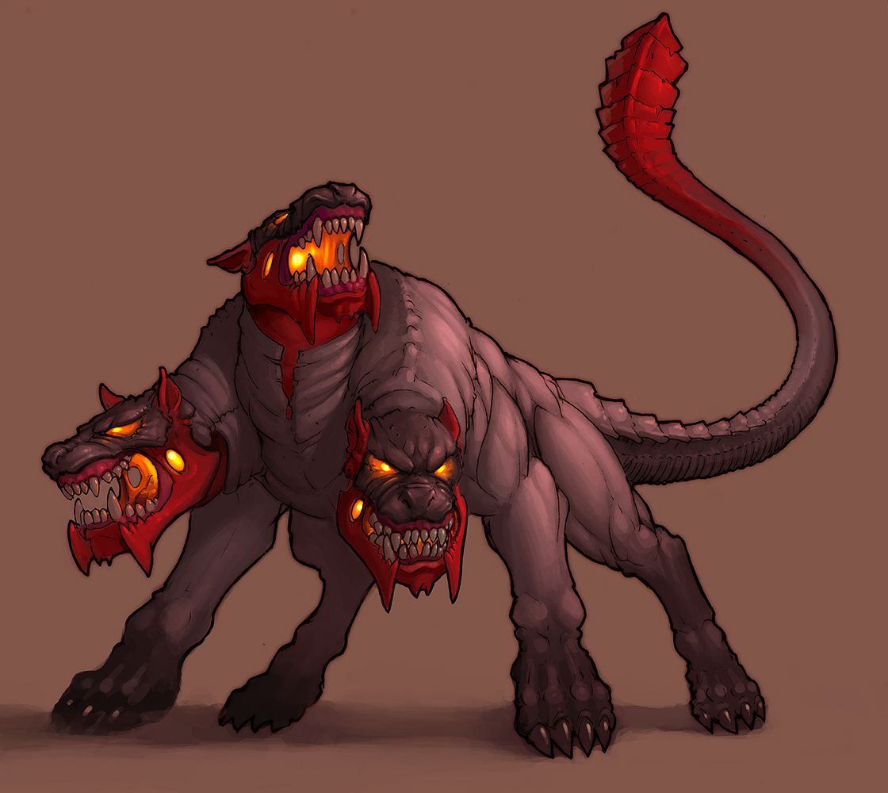
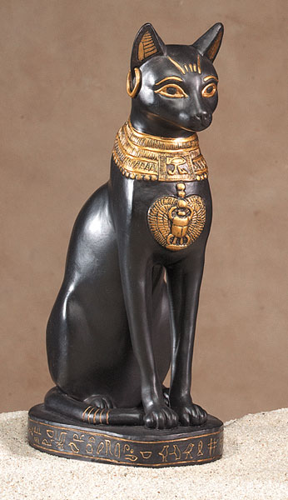





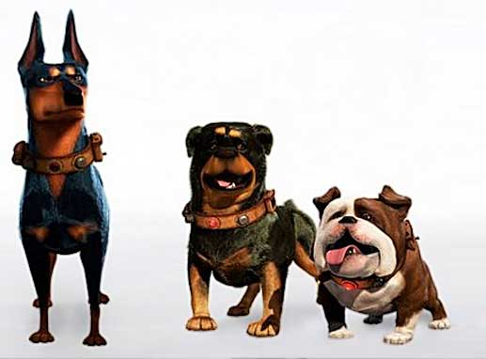


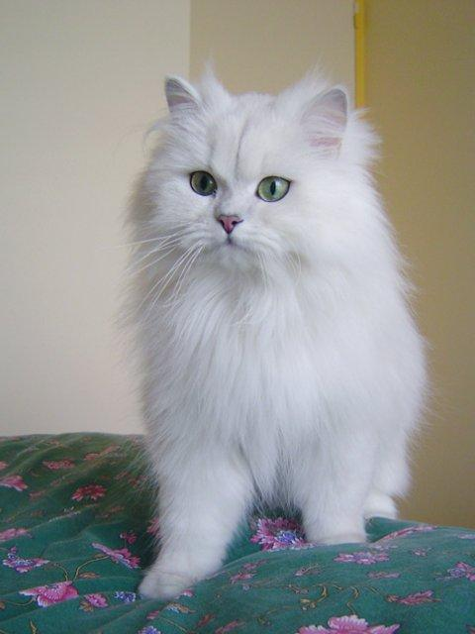
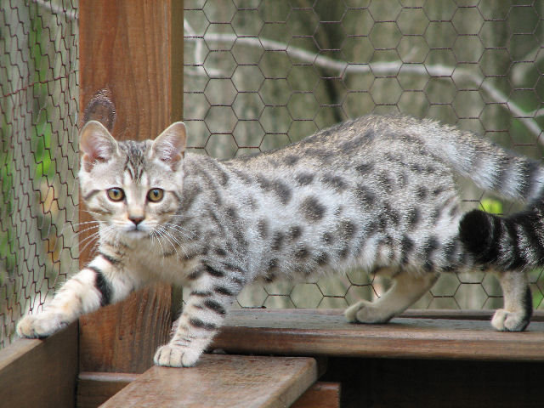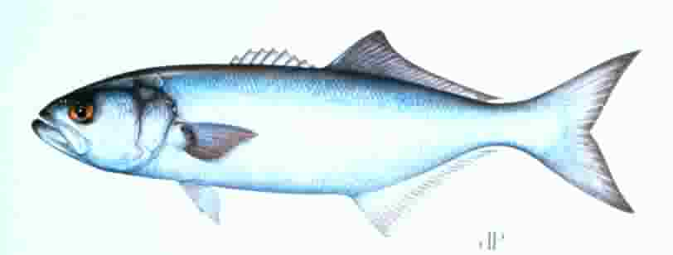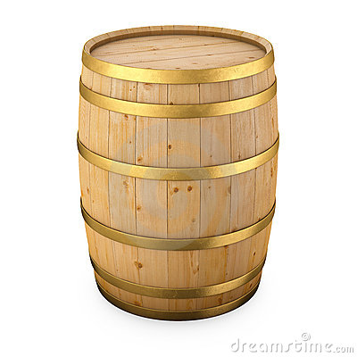
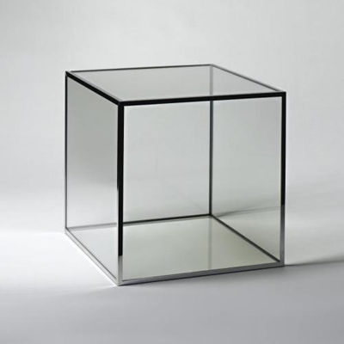
3.2 Level Design

3.2.A) Describe how and when is the third character skill is unlocked in this level.

The third character skill is unlocked after recruiting either a cat or dog ally. A cat can be easily recruited by going past it, but the player must fight the dog and defeat it in order to recruit it.

3.2.B) What will you do to ensure players understand its use and master it immediately?

I will have a text pop up saying, “Double tap to switch players.” until the player uses it. After the player uses the third skill, he or she will understand what it does and will know how to use it.

3.2.C) Use all the elements you’ve just defined to build a level.

The level should feature all the surfaces, design elements and enemies you have described in this test.

The constraints are the following:

Max level size: 8000*2400 pixels (width*height)

Max character size: 70*115 pixels (width*height)

(These are max values so they could vary if you think it’s appropriate)
3.3 Fake Screenshot

Using whatever bitmap editor you want, make a fake screenshot of your game

Constraint:

Screen size: 800*480 pixels (width*height) – landscape format

